CURRICULUM VITAE | 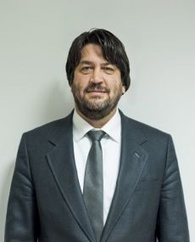

COMPANY NAME : YDU Engineering Machinery and Construction Industry Trade Co. Ltd.
NAME OF STAFF : ALİ ÜNAL GÖK

PROFESSION : CIVIL ENGINEER
DATE OF BIRTH : 1966
NATIONALITY: Turkish

MEMBERSHIP OF PROFESSIONAL SOCIETIES : MEMBER OF THE CHAMBER OF
CIVIL ENGINEERS / Ankara Branch
Membership No: 37222

KEY QUALIFICATIONS:
8 years of experience in importing, procurement, marketing and sales, 7 years of experience in construction of highways, housings, infrastructure, pipeline construction and concrete works. Preparation of detailed work schedule and resources requirements. (Materials, equipment, man power, time, money, design and logistic) Coordination of all logistic activities related site. Preparation of monthly progress report for Client and Consultant. Control of Monthly payment report. Preparation of site budget, and cash flow schedule for period of project and the comparison in every month of the contractor for numerous construction projects.

EDUCATION: Middle East Technical University
Department of Civil Engineering 1989

EXPERIENCE RECORD :

1999 – Present GYG ENGINEERING CO. LTD. + ENERMAK ENERGY CO. LTD., Ankara Turkey
Procurement Manager, Company Partner and Member of Management Board both in GYG Engineering and ENERMAK Energy.

Responsibilities include: My task is handling the business relations and correspondence with the foreign companies and suppliers, importing all the materials&goods needed for our marketing activities and also following up and completing the shipment of the goods and their custom clearance procedures. In addition to those my task is also procurement of the materials needed for our construction works. Also giving support to Sales Manager in planing, organizing and managing all sales activities, customer visits and sales meetings.

1998 – 1999 ATLAS COPCO COMPRESSORS
SALES ENGINEER for the Industrial Compressors in Central Anatolia Region

My task was all planing, organizing and managing all sales activities, customer visits and sales meetings. Also making market researches and finding new potential customers and monitoring them in my area.

1997 – 1998 THE SHELL COMPANY OF TURKEY LIMITED
TERRITORIAL SALES MANAGER RESPONSIBLE FROM ADANA-MERSIN REGION

My task was monitoring, promoting and increasing the fuel&lubricant sales and monitoring and maintaining the service quality in retail outlets, i.e. fuel stations in my area of responsibility, reporting my activities and sales of the oulets regularly to the Head Office each in a week. Also planing, organizing and launching new and different promotional campaigns together with the dealers in my territory. Organizing functional sales meetings with the dealers in my territory. During my job in this region, a 22 % of increase in lubricant sales has been achieved.

1996 – 1997 THE SHELL COMPANY OF TURKEY LIMITED
TERRITORIAL SALES MANAGER RESPONSIBLE FROM ANKARA REGION

My task was monitoring, promoting and increasing the fuel&lubricant sales and monitoring and maintaining the service quality in retail outlets, i.e. fuel stations in my area of responsibility, reporting my activities and sales of the oulets regularly to the Head Office each in a week. Also planing, organizing and launching new and different promotional campaigns together with the dealers in my territory. Organizing functional sales meetings with the dealers in my territory.

1994 – 1995 THE SHELL COMPANY OF TURKEY LIMITED
PROCUREMENT SUPERVISOR IN HEAD OFFICE / ISTANBUL

My task was including many activities on procurement chain such that vendor research and evaluation, organizing tenders for purchasing goods and services needed, evaluating the bids offered by the bidders, making contracts with the bidders, monitoring the payments to the contractors and controlling their compliance with the contract conditions.

1992 – 1994 THE SHELL COMPANY OF TURKEY LIMITED
MATERIALS AND ADMINISTRATIVE SUPERVISOR IN ANKARA LIAISON OFFICE

My task was importing all the materials needed by our drilling and production company for crude oil located in South East of Turkey including the activities of correspondence with the foreign suppliers, following up the shipment of the goods and necessary documents for the custom clearance procedure, organizing the custom clearance of the goods, forwarding them to the drilling and production site.

1991 – 1992 E.B.İ. ENERGY COMPUTER AND CONSTRUCTION INC.
CONSTRUCTION MANAGER
PROJECT NAME : CONSTRUCTION OF TEKNOPARK CENTER IN METU CAMPUS.
CLIENT : METU – KOSGEB
CONSULTANT : METU (MIDDLE EAST TECHNICAL UNIVERSITY)
EBI INC. is a company established by a METU foundation for construction purposes not only inside METU Campus but also in the outside of the Campus. This center was built for a permanent and growing cooperation between private sector companies and METU to invest and research for the new technologies including many research laboratories and offices inside.

Brief Technical Information : Teknopark Center
Concrete: 1500 m3 excavation : 2500 m3 reinforced steel : 150 tons. Formwork: 8000 m2
Total closed area is 5000 m2.
Including all infrastructure and substructure ( telephone, electricity, waste water, water, installation of electronic security and computer cable systems ).

My task was preparation of work programs, cost analysis and cash flow diagram. Estimating the required staff, equipment, and materials, preparation the contract for subcontracts. Selection of all materials. Estimating the necessary sources. Organizing the purchasing. Establishing the site. Quality control, and organizing the subcontractors

1990 – 1991 MILITARY SERVICE
RESERVE OFFICER IN CHARGE OF ALL KINDS OF CIVIL ENGINEERING WORKS/ACTIVITIES AT ARMOURED FORCES IN ETİMESGUT / ANKARA.

1989 – 1990 ENKA BECHTEL JOINT VENTURE
FIELD ENGINEER AT MARKUŞA CAMP

PROJECT NAME : ANKARA-GEREDE AND ANKARA PERIPHERAL MOTORWAY PROJECT
CLIENT : GENERAL DIRECTORATE OF HIGHWAYS
CONSULTANT : KUTLUTAŞ SWK JV

Brief technical information about the project :
Civil works: 1.046.687 m3 concrete 104.931 ton re-bar. 161.013.454 m3 excavation 114.376.728fill, 5.674.885 m3 subbase 1.805.158 m3 ctb and 5.077.450 ton asphalt pavement.

My Task was:
To decide method of statement of general project management. And method of statement of how to proceed of earthworks and finishingworks. Including all mobilization plans, organizations.
Preparation of detailed work schedule and resources requirements. (Materials, equipment, man power, time, Preparation of monthly progress report for Client and Consultant. Control of Monthly payment report. Preparation of site budget, and cash flow schedule for period of project and the comparison in every month. To prepare of cost control analysis. To get the approved drawings from design office at the right time. To prepare material take off list and give a purchase order to logistic and procurement department. To monitor the progress on daily bases and to take all necessary precautions accordingly.
To manage and direct subcontractors, to make all necessary correspondences. etc.

FOREIGN LANGUAGES:
Speaking Reading Writing

English excellent excellent excellent
Turkish mothertongue

CERTIFICATION :
I, the undersigned, certify that to the best of my knowledge and belief, this biodata correctly describes myself, my qualifications and my experience.

Signature : Date : 25.05.2017

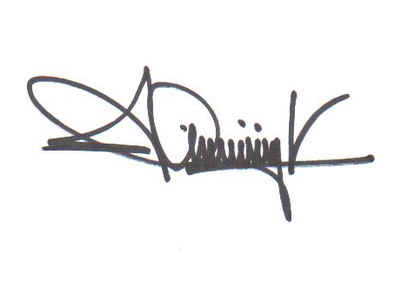

PROPOSED POSITION :

